
MURES COUNTY COUNCIL
MURES COUNTY'S POLICE INSPECTORATE

RISKS IN MUREŞ COUNTY’S TRAFFIC!
KEEP INFORMED!

RISK AREAS IN MUREŞ COUNTY’S TRAFFIC!
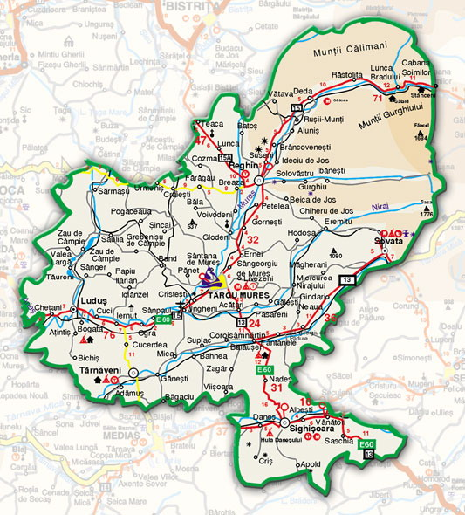
CHEŢANI
CUCI
SÂNPAUL
TG-MUREŞ
PETELEA
BRÂNCOVENEŞTI
SG.DE PĂDURE
BĂLĂUŞERI
SIGHIŞOARA
VÂNĂTORI

CHARACTERISTICS OF THE RISK AREAS:

DN 15 E 60 : CHEŢANI – CUCI – SÂNPAUL – UNGHENI

- Road area allowing high speed, followed by dangerous curves;
- Passers-by’s presence on the road;

DN 13 E60 : BĂLĂUŞERI – SIGHIŞOARA – VÂNĂTORI

- Road area allowing high speed;
- Extremely dangerous curves, low visibility;
- In certain villages housing buildings are too close to the road;
- Passers-by’s presence on the road;

DN 13A: TÂRGU-MUREŞ – SÂNGEORGIU DE PĂDURE – SOVATA

- Road area allowing high speed;
- Extremely dangerous curves, low visibility;
- In some villages there are no side-walks/alleys for passers-by (Passers-by’s presence on the road);

DN 15: TÂRGU-MUREŞ – PETELEA – BRÂNCOVENEŞTI

- Road area allowing high speed;
- Extremely dangerous curves, low visibility;
- Passers-by’s presence on the road.

WHY ARE DRIVERS FROM OTHER COUNTIES INVOLVED IN MORE THAN 50% OF THE SERIOUS ACCIDENTS?

- Situated in the center of the country, Mureş County is characterized by intense traffic;
- When driving a long time, the focus and the distributed attention diminish;
- Drivers from other counties are not aware of the road’s patterns, which:
- allow high speed driving, BUT
- have many extremely dangerous curves;
- cross localities, which implies the passers-by’s presence on the roads.

DRIVE SAFE! YOUR FAMILY IS WAITING AT HOME!

